Date: 26.4.19
DAILY REPORT ON WIT & WIL
Name of the Faculty : Dr. S. NAGINI Name of the subject : Programming through C
Class/ Section : I B.Tech II sem CSE – C
1 | Grid Reference No : | 3.1
2 | Scenario Reference: | 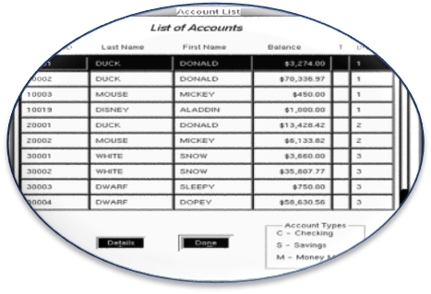
3 | Topic Covered: | Sorting(Insertion Sort)(revision)
4 | Brief Write – up (500 words):  Sorting is any process of arranging items systematically, and has two common, yet distinct meanings: ordering: arranging items in a sequence ordered by some criterion; categorizing: grouping items with similar properties.  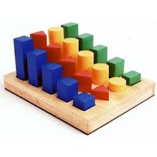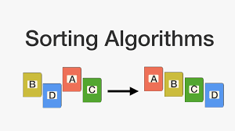  Insertion Sort:  Insertion sort iterates, consuming one input element each repetition, and growing a sorted output list. At each iteration, insertion sort removes one element from the input data, finds the location it belongs within the sorted list, and inserts it there. It repeats until no input elements remain.  Sorting is typically done in-place, by iterating up the array, growing the sorted list behind it. At each array-position, it checks the value there against the largest value in the sorted list (which happens to be next to it, in the previous array-position checked). If larger, it leaves the element in place and moves to the next. If smaller, it finds the correct position within the sorted list, shifts all the larger values up to make a space, and inserts into that correct position.  Following are the steps involved in insertion sort:  - We start by making the second element of the given array, i.e. element at index 1, the key. The key element here is the new card that we need to add to our existing sorted set of cards(remember the example with cards above).  - We compare the key element with the element(s) before it, in this case, element at index 0:  - If the key element is less than the first element, we insert the key element before the first element.  - If the key element is greater than the first element, then we insert it after the first element.  - Then, we make the third element of the array as key and will compare it with elements to it's left and insert it at the right position.  - And we go on repeating this, until the array is sorted.  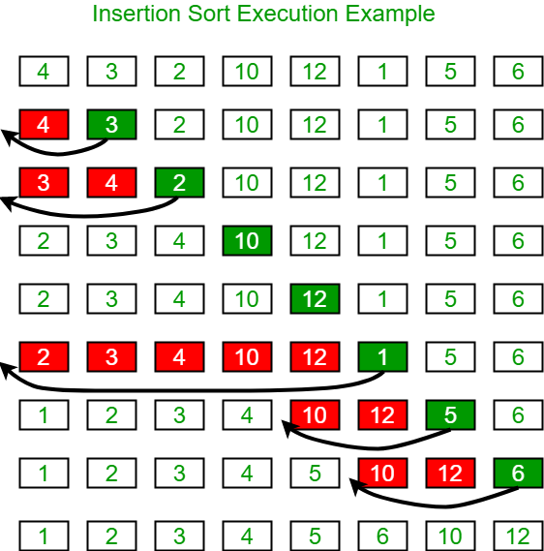  ATM Example:  Once each bag’s amount is confirmed, the money gets fully under the control of cash center. And money from all cash bags are mixed together. Now all denominations are mixed.  If customer want all banknote sorted in one direction, cash center does Orientation Sorting. All banknotes go into banknote sorter together and sorted in their orientation. Now all banknotes are in one orientation, though all denominations are mixed.  5 pocket counter is an ideal choice to do Orientation Sorting because there exist 4 orientations: Face Up, Face Down, Bottom Up, Bottom Down.  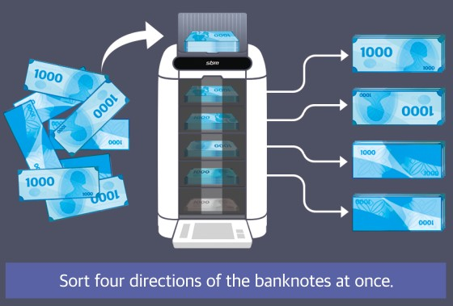  Denomination Sorting  Now each denomination should be sorted. Ideal number of pockets depends on the number of denominations. Usually each currency has 4~7 denominations.  For example, for South Korean Won with 4 denominations, a 5 pocket machine to sort 4 denominations would be the best choice.  For USD or EUR with 7 denominations, cash center has 3 choices: one 5 pocket machine, two 5 pocket machines, one 8 pocket machine.  One 5 pocket machine costs least, and ideal if only one operator is allocated for this task.  Two 5 pocket machine costs twice but processing speed doubles. It is ideal if two operators are allocated for this task.  One 8 pocket machine is fastest solution. However, it costs 5~10 times more than 5 pocket solutions. It is best choice if cash processing speed is extremely important and operator’s salary is high enough to invest a lot into very expensive machines.  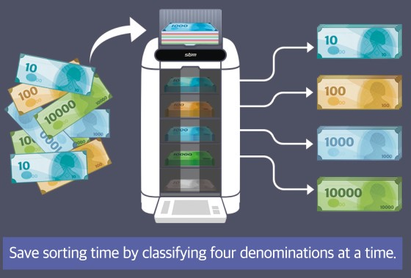  Fitness Sorting (Optional)  Some customer wants to receive only fit (clean) banknotes to fill in ATM. In that case, fitness sorting should be done.  There are 3 choices for fitness sorting  2 pocket is cheapest, but slowest because machine stops every 100 pieces of fit notes and rejected banknote should be counted again. It can be a choice for small bank branch back office, but not recommended to cash center.  3 pocket is more expensive than 2 pocket, but faster because fitness sorting can be done at a time. However, 3 pocket machine also stops every 100 pieces of fit/unfit notes to empty the full pocket. This choice is good for cash center where fitness sorting demand is not high.  5 pocket is more expensive than 3 pocket, but fastest because fitness sorting can be done at a time and does not stop at all. This choice is best for cash center which has to handle large volume of cash.  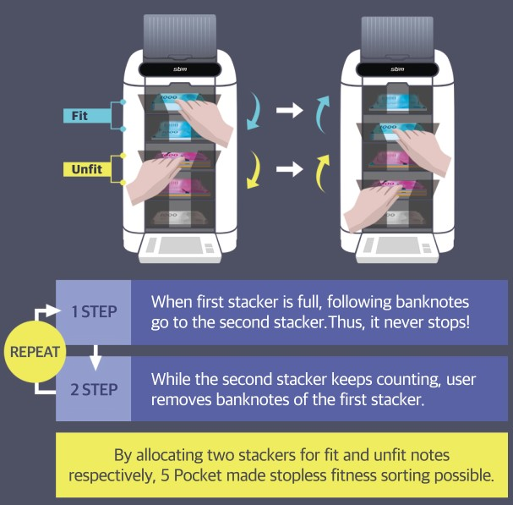
5 | Relevant additional illustration if any : Soda Vending Machine
6 | Video links / web links if any: | https://www.youtube.com/watch?v=UAmaFHWBoYQ  https://www.youtube.com/watch?v=_EV6xAXf5FA
7 | Signature of Repository Administrator:

